API Management & Security
- Implementing Policies in APIM
Business Scenario
Our company exposes an API/set of APIs.
Requirements:
  - Expose API(s) through APIM
  - Validate JWT token
  - Limit calls to 60 requests/minute
  - Add correlation ID
  - Transform backend URL
  - Cache GET responses
  - Hide backend details
  - Return custom error messages
  - Log request details
Policy Flow
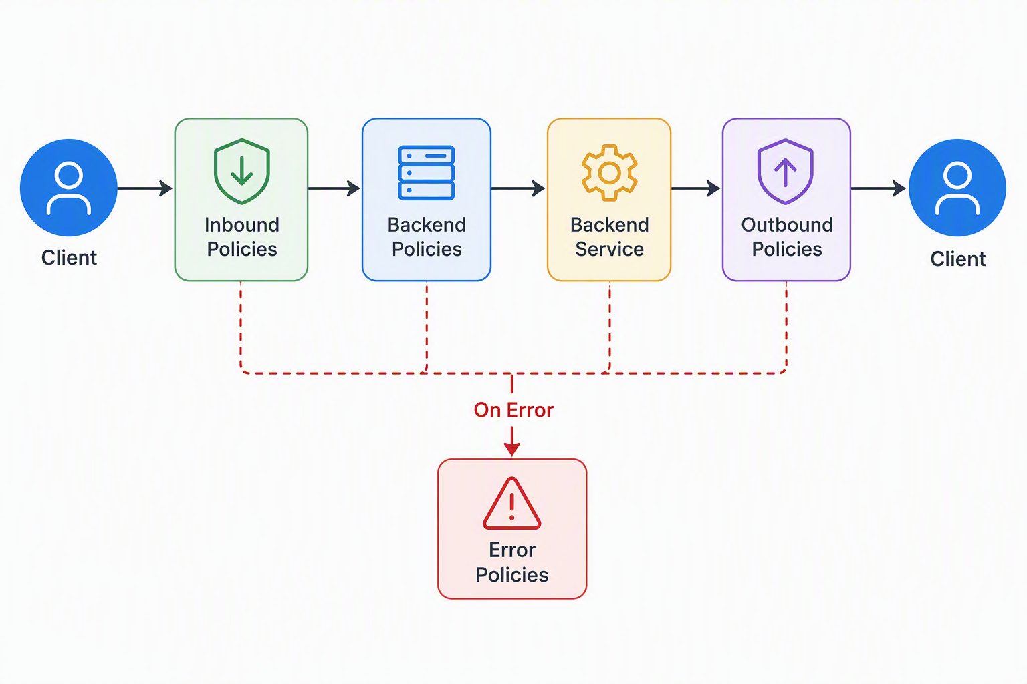

Caching Responses
First request
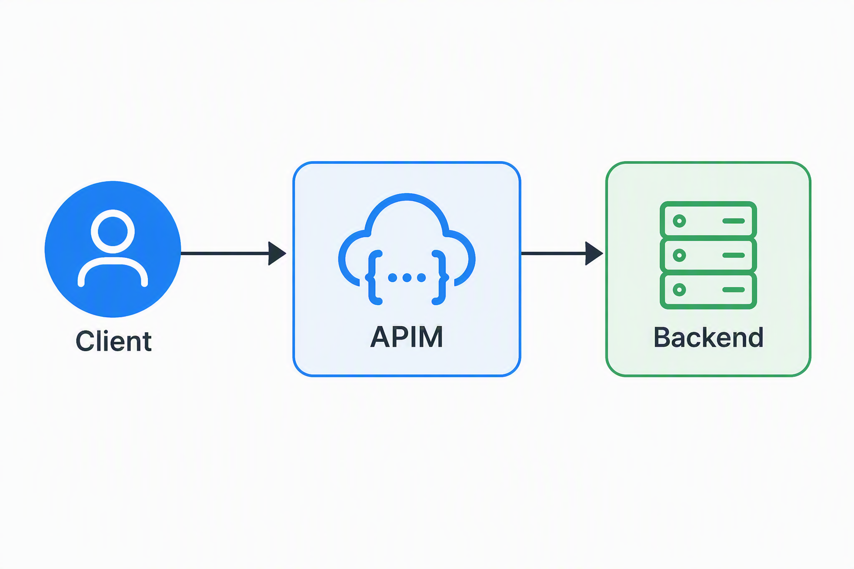
Subsequent Requests
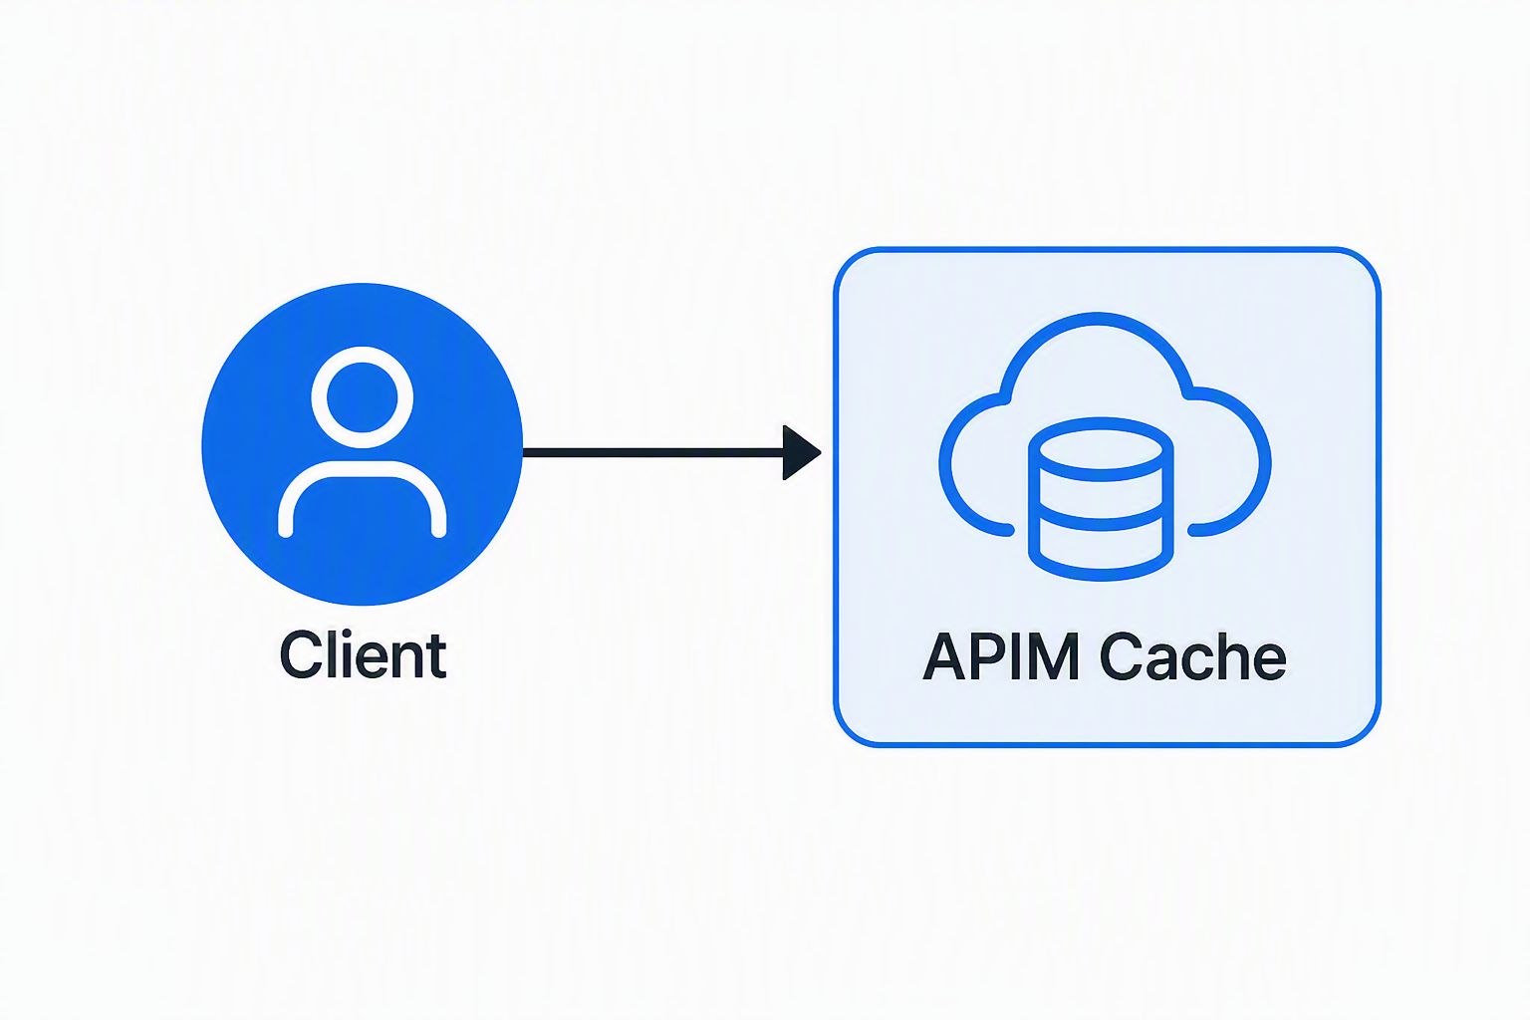
Benefits:
- Lower latency
- Reduced backend cost

- API Security (via Azure APIM)
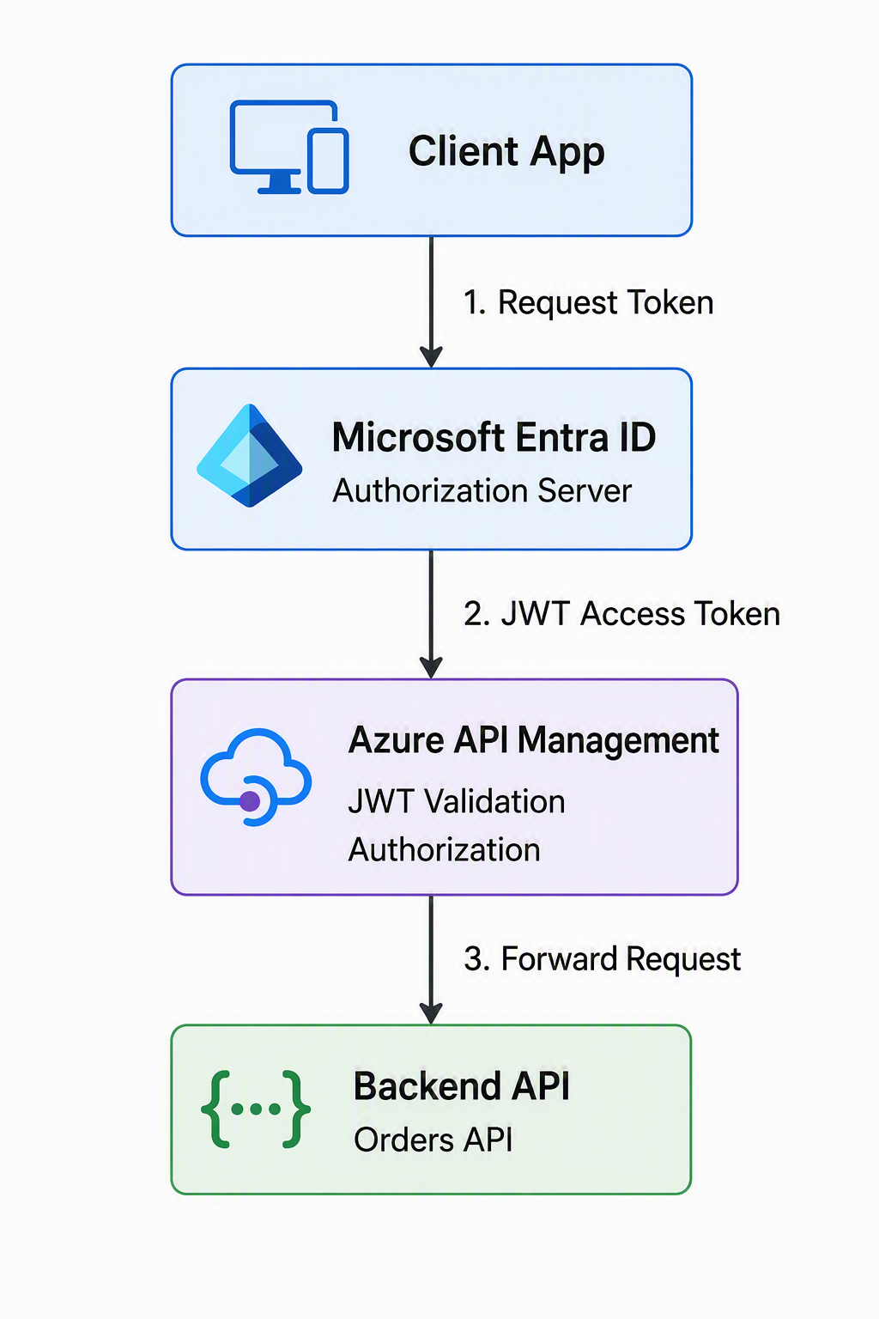
For enabling Azure Entra ID based Authentication & Authorization, we need the following steps to be carried out:
- Register Backend API in Azure Entra ID (App Registration)
- Expose API
- Create App Roles
- Register the Client Application
- Grant User Access
- Obtain OAuth2 Access Token
- JWT Token Contains Claims
- Import API into APIM
- Configure Authentication (JWT Validation)
- Authorization using Roles
- Different Authorization Per Operation
- (Optional) Add subscription key

